Exercise 6

Machine Learning I

|  |  |
| --- | --- |
|  | 6A-1. |

First, rearrange through Bayes theorem:

$$p\left(t|X\right)=\frac{p\left(t|w,X\right)p\left(w|X\right)}{p\left(w|t,X\right)}$$

Decompose:

$$\log{p\left(t|X\right)}=\log{p\left(t|w,X\right)}+\log{p\left(w|X\right)}-\log{p\left(w|t,X\right)}$$ Now we can just plug in the values from the previous exercises and slides. No need to recompute everything again:

$$\begin{matrix}\log{p\left(t|X\right)} & =… \\ & +\frac{1}{2}{\left(w-τ_{e}Σ_{N}Φ^{T}t\right)}^{T}{\left(Σ_{0}^{-1}+τ_{e}Φ^{T}Φ\right)}^{-1}\left(w-τ_{e}Σ_{N}Φ^{T}t\right)\end{matrix}$$ TODO

|  |  |
| --- | --- |
|  | 6A-3. |

The noise $ϵ$ is symmetric around $t$. So by the same way we derived $t\sim N\left(t;w^{T}x,ϵ\right)$ when the noise was normal, we can now say

$$t\sim Stud_t\left(t;ν,w^{T}x,σ_{ϵ}^{2}\right)$$

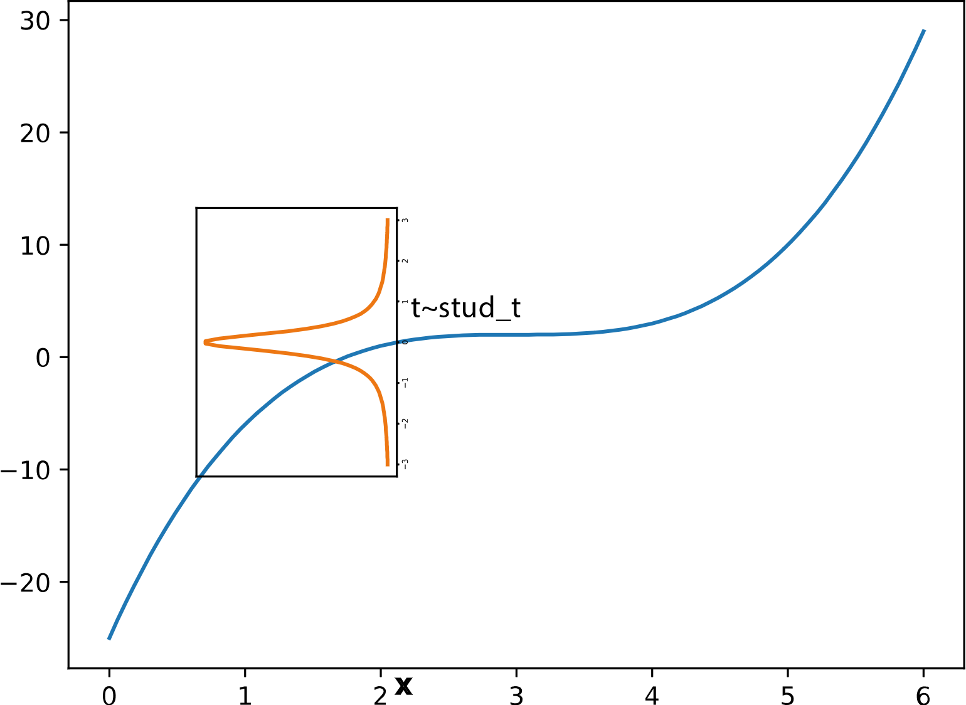

Figure 1 Because the noise is symmetrically distributed around $t$ and the   
hidden function f(x) is non-random (p(t|x)=1 for one value of t), $t$ is identically distributed  
to its noise with adjusted mean.

This leads to the log likelihood:

$$\begin{matrix}\log{p\left(t|x,ν,σ_{ϵ}\right)} & =\log{\prod_{i=1}^{n}{Stud_t\left(t_{i};ν,w^{T}x_{i},σ_{ϵ}^{2}\right)}} \\ & =n\left[\log{Γ\left(\frac{ν+1}{2}\right)}-\log\left(\sqrt{νπσ_{ϵ}^{2}}Γ\left(\frac{ν}{2}\right)\right)\right] \\ & -\frac{\left(ν+1\right)}{2}\sum_{i=1}^{n}{\left(1+\frac{1}{ν}\frac{\left(t_{i}-w^{T}x_{i}\right)}{σ_{ϵ}^{2}} \right)}\end{matrix}$$

Let us set $d=\left(t_{1}-w^{T}x_{1}\right)$. We now plot the error of one datapoint in comparison to a log normal pdf. The following picture was attained with the parameters $σ$

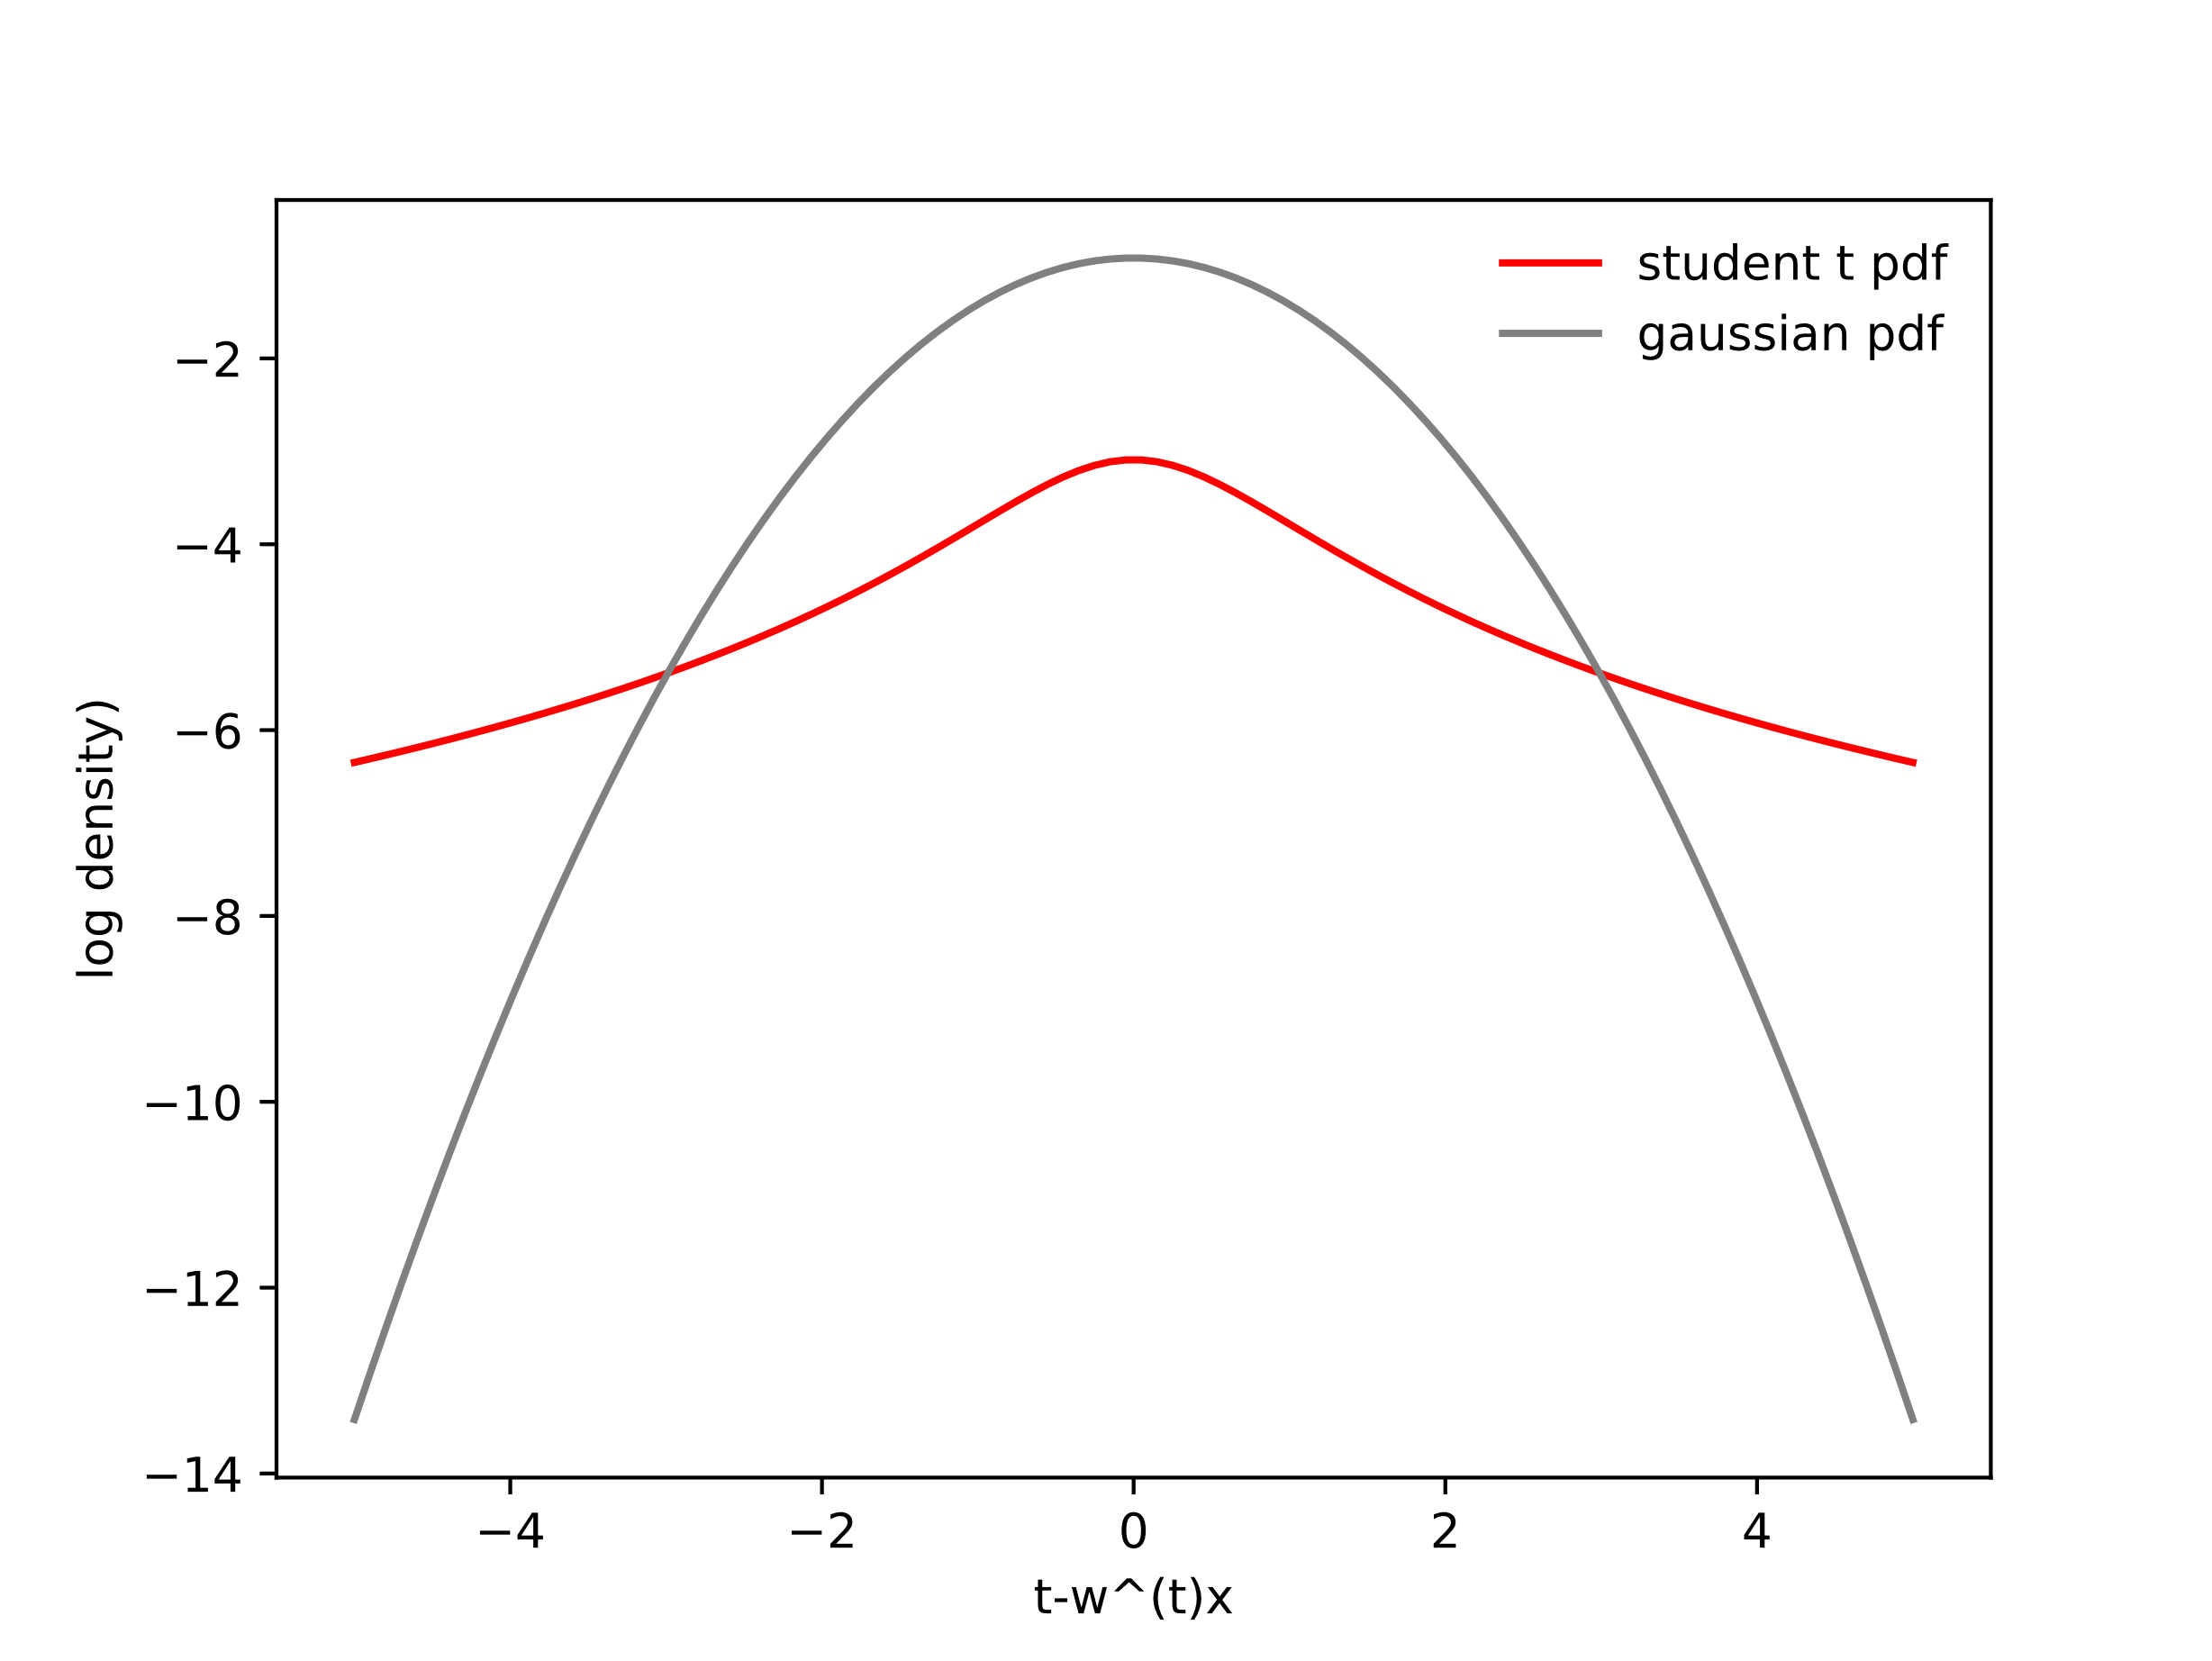

Figure 2 Comparison of the test error between a log normal pdf and  
a student t pdf. Image was attained with the parameters $σ_{ϵ}=1, ν=1$.

For small errors $w^{T}x≈t$, the student t distribution appears to be less forgiving, as less density is concentrated around small errors ($\log{Stud_t\left(t_{1};1,d,1\right)}<\log{N\left(t_{1};d,1\right)}$). Larger errors $\left|w^{T}x\right|≫\left|t\right|$ are less penalized however, as $\log{N\left(t_{1};d,1\right)}<\log{Stud_t\left(t_{1};1,d,1\right)}$.

Generally speaking, this means if we try to maximize our weights $w$ with respect to $e\sim N\left(0,σ^{2}\right)$, then our fit is trying to mitigate large errors while being mostly indifferent to smaller ones.  
If we maximize $w$ with respect to $t\sim Stud_t\left(t;ν,w^{T}x,σ_{ϵ}^{2}\right)$, we get a more balanced fit, we small deviations are considered.